Nama : Hafizh Umar Syafiqh

NIM :18090138

Kelas : 5D

**PRAKTIKUM 6**

1. Source Code

autoload.php => application/config

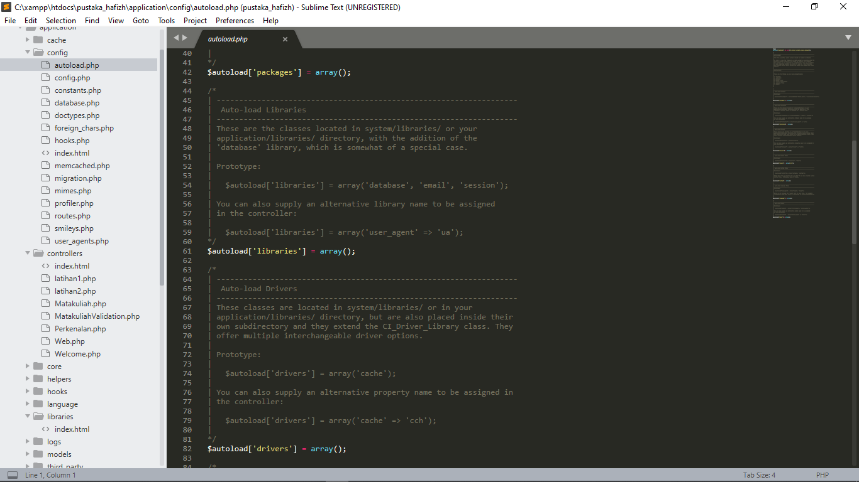

database.php => application/config

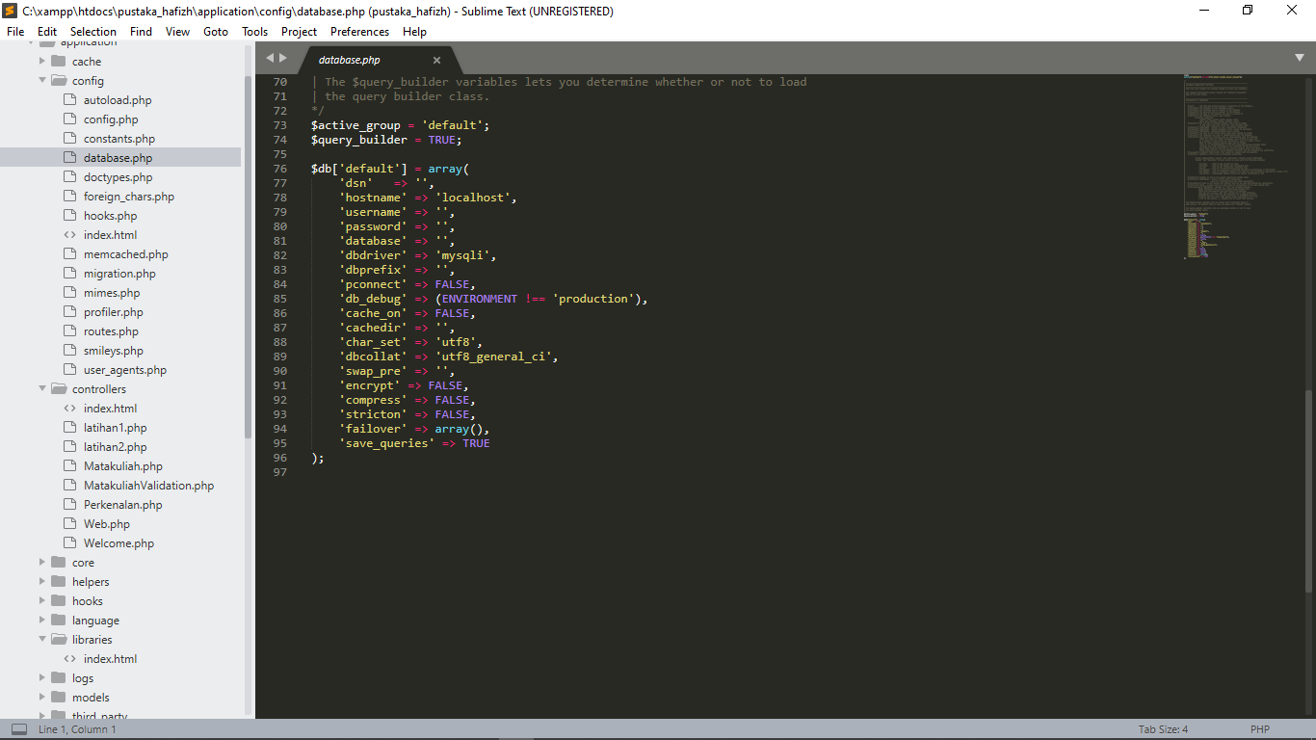

modelUser.php => application/model

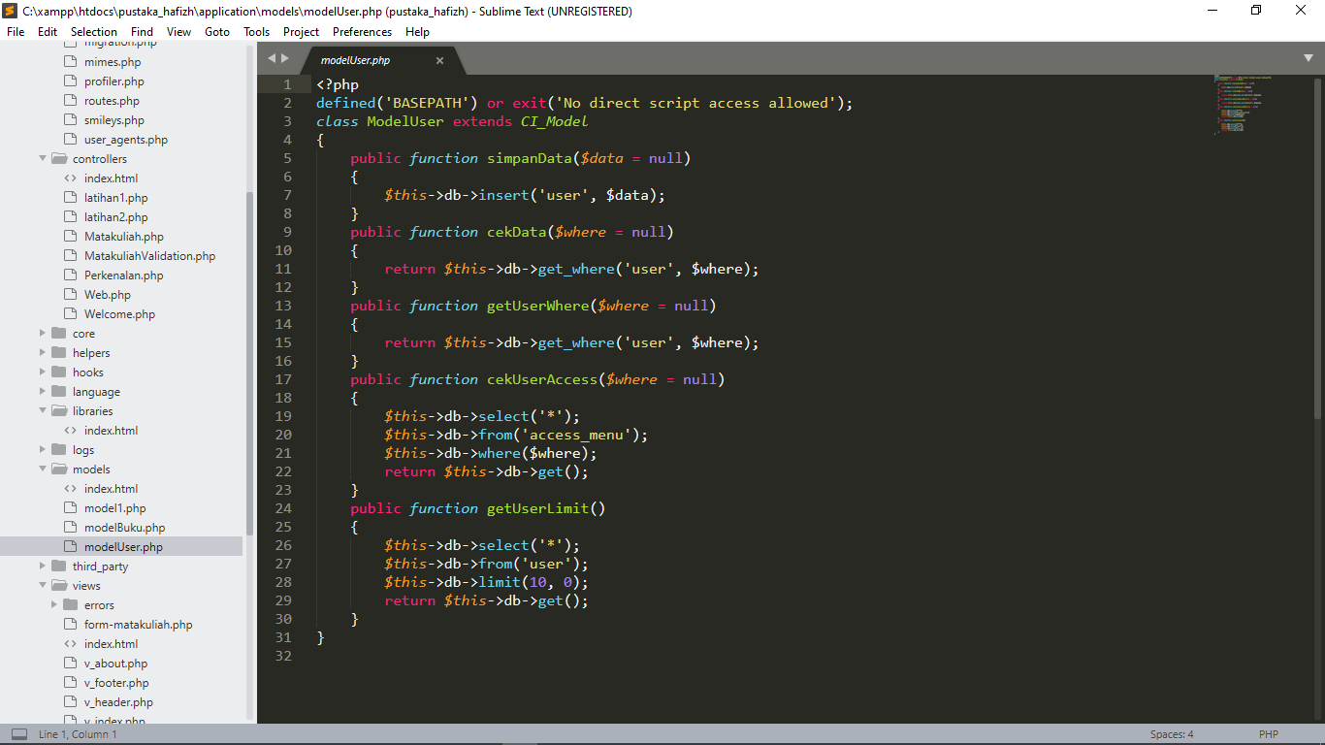

modelBuku.php => application/model

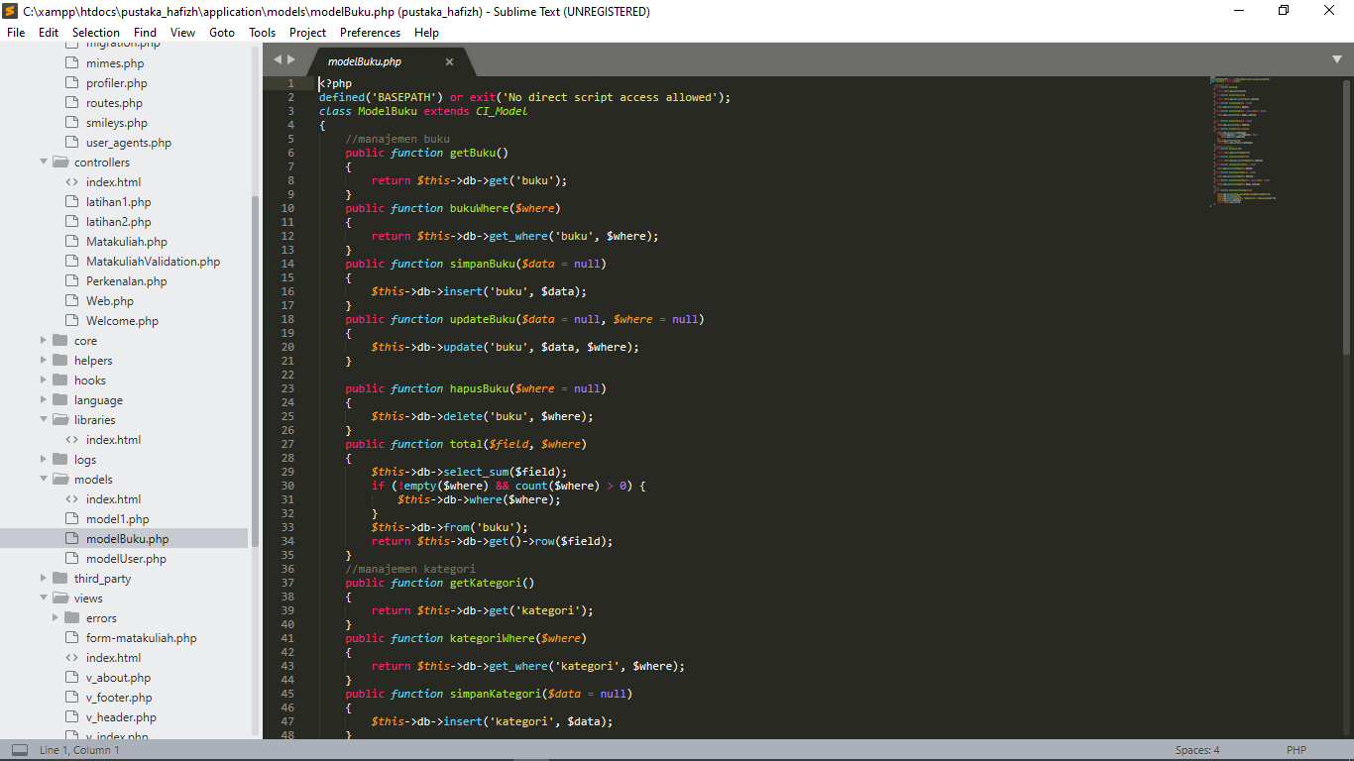

1. Membuat database
   1. pustaka_hafizh
   2. Membuat table user
   3. Membuat table buku
   4. Membuat table role
   5. Membuat table katogori
2. URL

<http://localhost/phpmyadmin/db_structure.php?db=pustaka_hafizh>

1. Capture Hasil

